Blood Assignment Name_________________________

/28

1. Jeff has blood type A and his wife Jean also has blood type A.
Their son, Joey has blood type O.
Explain how this is possible – use a punnet square diagram. (3)

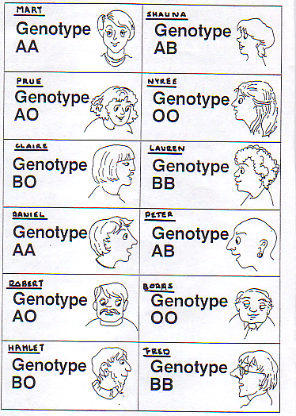
The following table will be used for many of the following questions:
2. Using punnet squares:
Determine the possibility of each blood type of the offspring of the following people:

- Claire and Fred (2)

- Lauren and Hamlet (2)

- Name all the possibilities of who would Mary have to marry to have children that could be Type A but NO other type? (3)

- If a child has blood Group AB, name TWO sets of parents that could produce this child.
Explain your answer using punnet square diagrams. (4)

BLOOD TRANSFUSIONS:

Refer to the table showing the genotypes of various people:

5a Boras requires a blood transfusion.
Who can donate blood to him? Explain your answer. (4)

5b Shauna would like to donate blood.
Who is able to receive a transfusion from Shauna? Explain your answer (4)

Rhesus Factor

Refer to the table showing the genotypes of various people.

Assume all the people in the left column are Rh positive, and all those in the right column are Rh negative.

6a Nyree and Daniel are going to have a baby together. (3)
Considering only their Rhesus factor - may this cause a problem? If so what and why?

6b Mary and Peter are going to have a baby together. (3)
Considering only their Rhesus factor – may this cause a problem? If so, what and why?

ANSWERS KEY ---- BLOOD ASSESSMENT
1. Jeff has blood type A and his wife Jean also has blood type A.
Their son, Joey has blood type O.
Explain how this is possible – use a punnet square diagram. Punnet = 2 marks
Explanation= 1 mark
 | I^{A} | i
I^{A} | I^{A}I^{A} | I^{A}i
i | I^{A}i | ii
or

 | I^{A} | i
I^{A} | I^{A}I^{A} | I^{A}i
i | I^{A}i | ii

2. Using punnet squares:
Determine the possibility of each blood type of the offspring of the following people:

- Claire and Fred (2) The genotypes are 50% chance I Bi or 50% chance IBIB
Possibility of each blood phenotype is type B Type Blood 100%

1 mark for answer and 1 mark for punnet

 | B | O
B | BB | BO
B | BB | BO
Or
 | I B | i
I B | IBIB | I B i
I B | IBIB | IBi

- Lauren and Hamlet (2) The genotypes are 50% chance I Bi or 50% chance IBIB
Possibility of each blood phenotype is type B Type Blood 100%

1 mark for answer and 1 mark for punnet

 | B | O
B | BB | BO
B | BB | BO

Or

 | IB | i
IB | IBIB | IBi
IB | IBIB | IBi

3. Find all the possibilities of who would Mary have to marry to have children (3)
that could be Type A but NO other type?

Daniel (AA x AA), Robert (AA x AO), Boras (AA x OO)
Minus 1 mark for each incorrect addition or each one missing

4. If a child has blood Group AB, name TWO sets of parents that could produce this child.
Explain your answer using punnet square diagrams. (4)

1 mark for each correct set (up to 2 marks)
1 mark for each correct explanation (up to 2 marks)

BLOOD TRANSFUSIONS:

Refer to the table showing the genotypes of various people:

5a Boras requires a blood transfusion.
Who can donate blood to him? Explain your answer. (4)

1 mark - Boras is blood group O This means he has no Antigens on RBC
1 mark - Boras has Anti-A and Anti-B antibodies in plasma

1 mark - Only can get a donation of blood from Group O as there are no Antigens to be exposed to and blood will not be rejected

1 mark - So Boras can only accept blood donation from Nyree as she is O group blood

5b Shauna would like to donate blood.
Who is able to receive a transfusion from Shauna? Explain your answer (4)

1 mark - Shauna’s blood is AB this means she has Antigen A and Antigen B in her RBC
1 mark - Her blood will not make Anti-A or Anti-B

1 mark - Shauna can donate blood only to AB group people

1 mark - The only person recipient with AB blood would be Peter who also has AB blood – he can receive the transfusion

Rhesus Factor

Refer to the table showing the genotypes of various people.

Assume all the people in the left column are Rh positive, and all those in the right column are Rh negative.

6a Nyree and Daniel are going to have a baby together.
May this cause a problem?
If so what and why?

Nyree ii Rh-
Daniel IAIA Rh+
 | i Rh- | i Rh-
IA  Rh+ | IAi Rh+ | IAi  Rh+
IA  Rh+ | IAi  Rh+ | IA i  Rh+

1 mark -All children AO Rh+ (this mark can go to punnet square)
1 mark - will cause a problem for the baby as the mother is Rh- OR If they say it will not be a problem as it is their first child so the mother probably does not have any Rh antibodies they can get

1 mark - Mother has Rh antibodies which will recognise the babies Rh+ as foreign and will attack them

6b Mary and Peter are going to have a baby together.
May this cause a problem? If so what and why? (3)

Mary IA IA Rh +
Peter IA IB Rh –

 | IA  Rh+ | IA Rh+
IA  Rh- | IAIA  Rh+ | IA IA  Rh+
IB  Rh- | IAIB  Rh+ | IAIB  Rh+

1 mark – (this mark can go to punnet square) Children all AB Rh+ or AA Rh+
1 mark - As mother is also Rh + this will not cause a problem
1 mark - mother does not have Rh antibodies

